Note:
Non-final variables can be reassigned.
Local variables have no default values and must be initialized before use.
Final variables (instance, static, or local) need not be initialized at declaration, but must be assigned exactly once in an appropriate place depending on their type.

🧠 One-Line Interview Version (Gold)
👉 Final enforces single assignment, non-final allows reassignment, and local variables require explicit initialization because they have no default values.

Eg: Local_Final_Variable_2
// go through the code

Eg: Variable_Declaration
// go through the code

Eg: Fizz
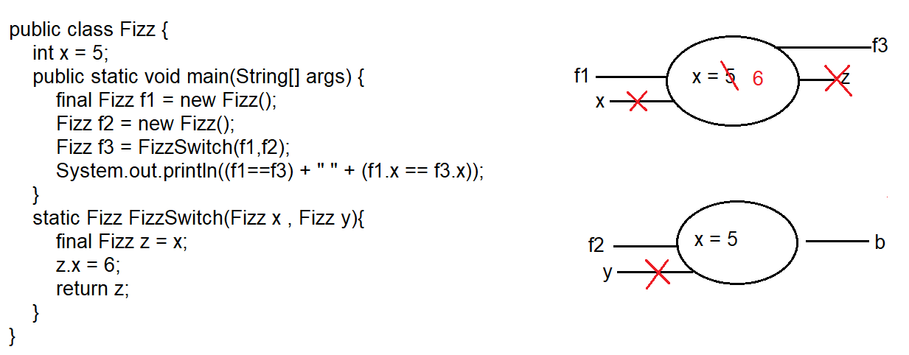

✅ Fully Corrected & Clean Explanation (Final Version)
- Control enters the main method and a final reference variable f1 is created pointing to a new Fizz object.
Declaring the reference as final prevents reassignment of the reference, not modification of the object.
- Another Fizz object is created and its reference is stored in f2.
- The static method FizzSwitch() is called using the class name and it has a return type of Fizz.
- The reference variables f1 and f2 are passed as arguments to FizzSwitch().
Inside the method, parameter x refers to the same object as f1, and y refers to the same object as f2.
- Inside the method, reference variable z is assigned the value of x, so z also points to the same object as f1.
- Using reference z, the instance variable x of that object is changed from 5 to 6.
- The method returns the reference z, which is stored in f3 in the main method.
- After the method execution completes, local variables x, y, and z go out of scope and are removed from the stack.
- Since both f1 and f3 refer to the same object, the expression (f1 == f3) evaluates to true.
- Since the instance variable x of that shared object is 6 for both references, (f1.x == f3.x) also evaluates to true.

Eg: ReturnType
// go through the code

✅ Correct Statement
👉 In a static method, instance variables can be accessed only through an object.

🔍 Why This Works
- Static method → belongs to the class
- Instance variable → belongs to an object
- So JVM needs an object reference to know which instance you mean

✅ Valid Example
class Test {

int x = 10; // instance variable

static void show() {

Test t = new Test(); // create object
System.out.println(t.x); // access instance variable using object
}

public static void main(String[] args) {
show();
}
}
✔ Here, t.x clearly tells JVM which object’s x to use.

❌ Invalid (Direct Access)
class Test {

int x = 10;

static void show() {
System.out.println(x); // ❌ Compile Time Error
}
}
Reason:
Cannot make a static reference to the non-static field x

🧠 One-Line Rule (Golden)
👉 Static methods cannot access instance variables directly, but they can access them indirectly using an object reference.

Eg: Counter
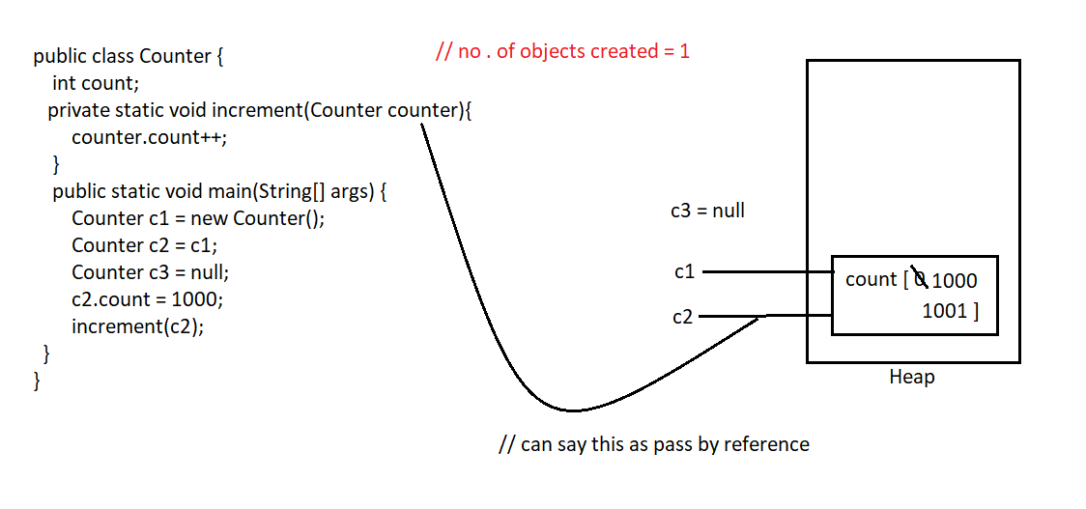

Eg: Counter_Eg2
// go through the code

Eg: Local_Variable_Eg6
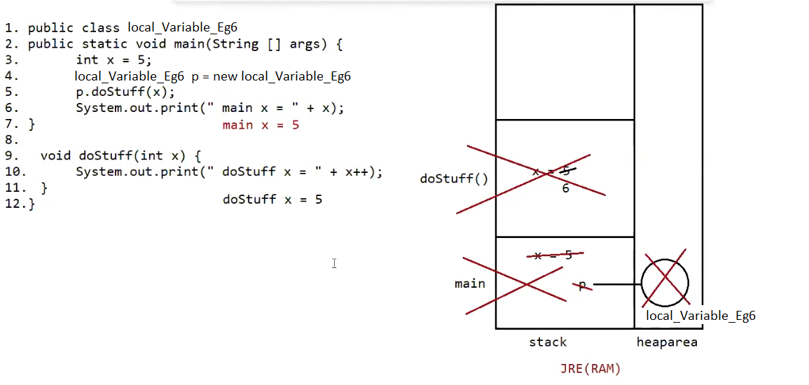

Eg: Tahiti
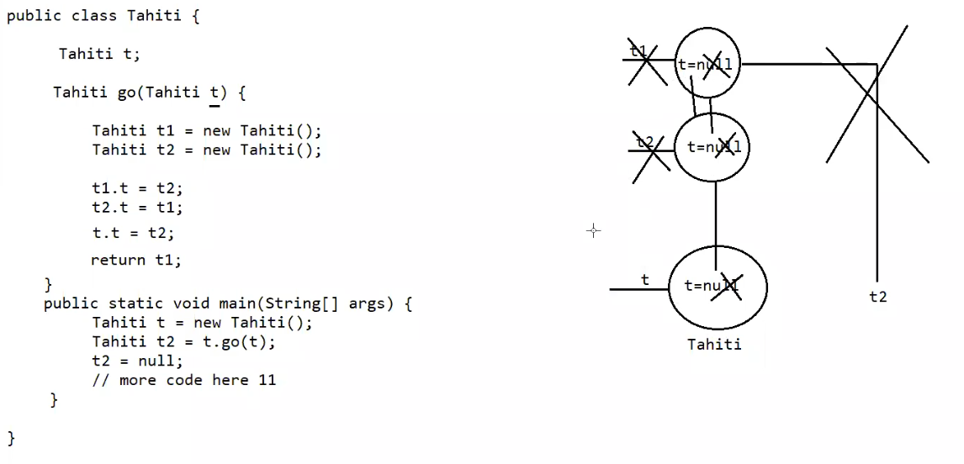
// go through the code

Eg: ItemTest
A final instance variable can be assigned only once, either at declaration or inside the constructor, and any reassignment attempt causes a compile-time error.

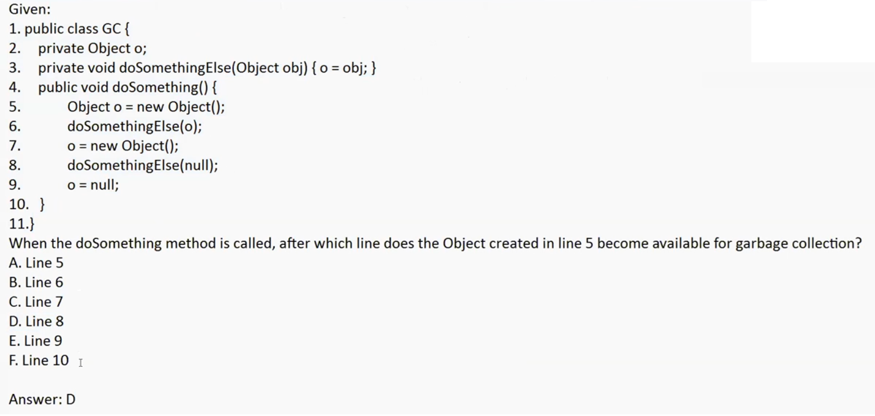

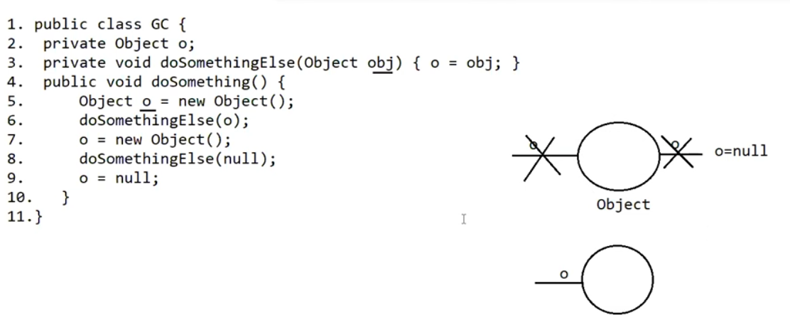
// go through the code

✅ 1. Object and Variables / Methods

An object stores data in variables and performs actions using methods.
- Variables → represent the state (what the object knows).
- Methods → represent the behavior (what the object does).
Example:
class Student {
String name; // state
void study() { // behavior
System.out.println("Studying...");
}
}

✅ 2. Object and Local Variables
- An object can access:
  - Instance variables
  - Instance methods
- An object cannot directly access local variables of a method.
Why?
A local variable exists only inside the method where it is declared.
It is created when the method starts and destroyed when the method ends.
Example:
class Demo {
int x = 10; // instance variable

void show() {
int y = 20; // local variable
}
}
You cannot do:
Demo d = new Demo();
System.out.println(d.y); // ❌ ERROR
Because y is local to show() method.

✅ 3. Accessing Local Variables
An object cannot directly access a local variable.
If you want to use a local variable, you must call the method that contains it.
Example:
class Demo {
void display() {
int num = 100;
System.out.println(num);
}
}
Usage:
Demo d = new Demo();
d.display(); // method uses local variable internally
👉 The object calls the method.
👉 The method uses the local variable.
👉 The object never directly sees the local variable.

